RR1 Archive Orders in RR2
There is now a section in RR2 under the Communities profile for RR1 Archive. This tab will list all orders from RR1 for the specific community including links to the approved documents.

Table: RR1Archive – Stores the information for RR1 sales. Each Management Company will have to be converted over one-by-one.
Activating the RR1 Archive tab – Since each management company has to be converted one-by-one, there is a flag under the Company table that will need to be set in order for the RR1 Archive tab to be visible. COArchive = 1
RR1 Archive Tab:
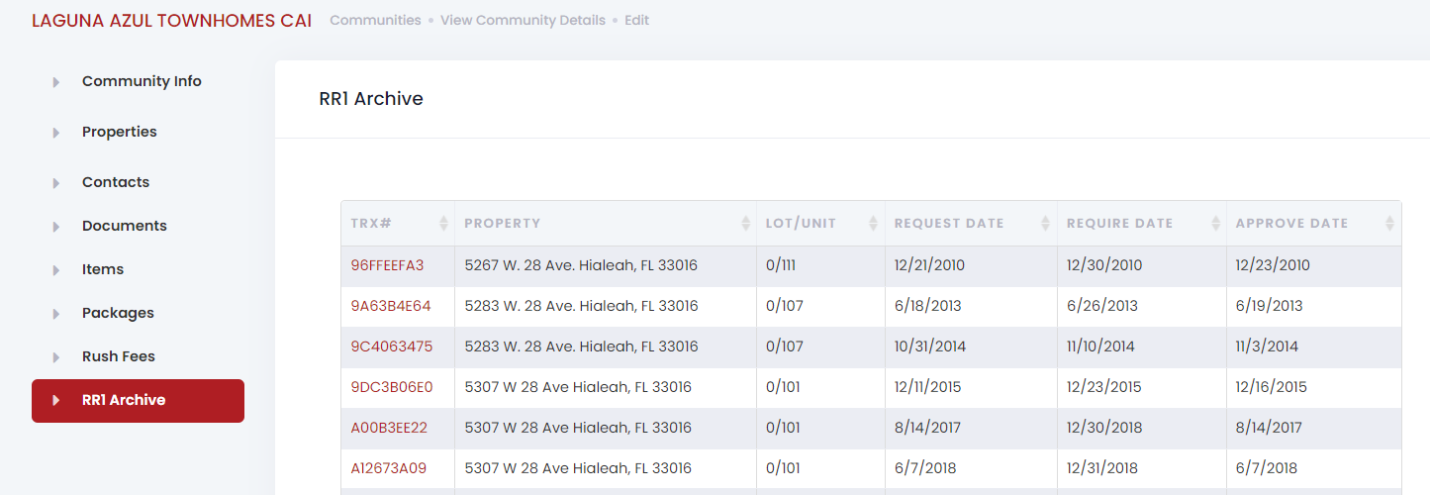
Clicking on the TRX# will display the details.

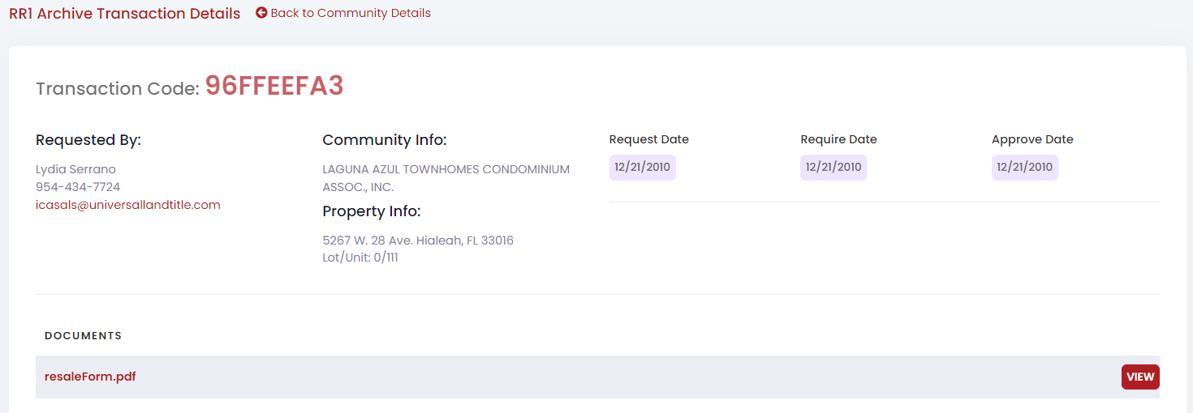
Clicking on the document name or view button will display the document.

